AMELIA’S TRIP FROM PHOENIX TO CALDAROLA

***The trip of Amelia to Caldarola started in Phoenix Az.***

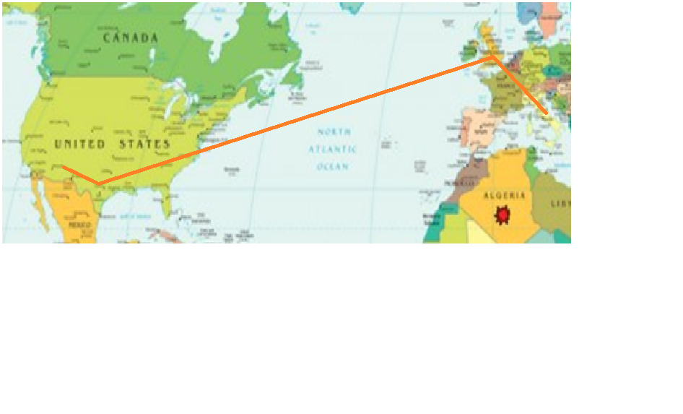

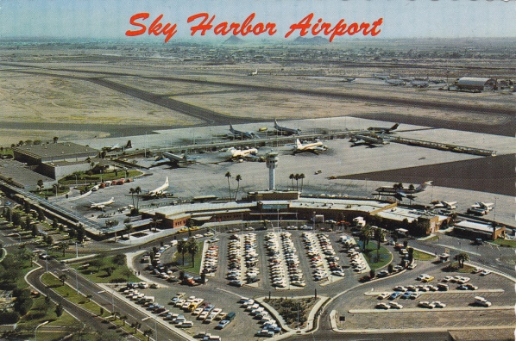***She left her house at 15:00 for Sky Harbor Airport in Phoenix.***

***It is very big and has got 4 terminals.***

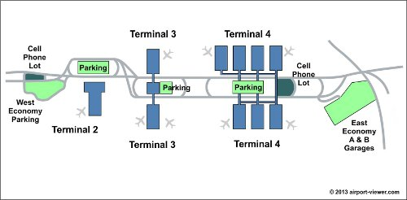

***From Phoenix to Dallas the flight was 3 hours.***

***Dallas is a very modern city.***

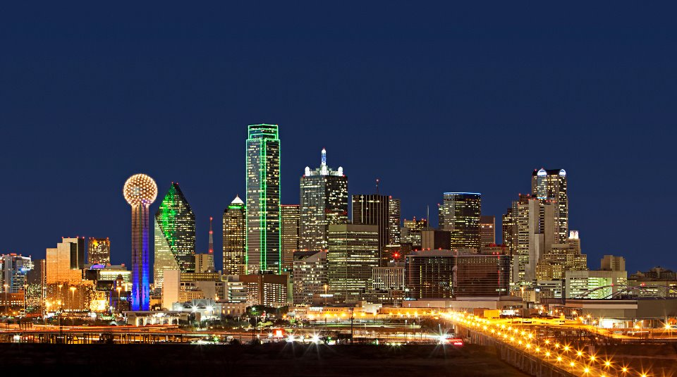***In Dallas there are many tall skyscrapers. There is a modern building. It’s very tall and on the top of this building there is a ball. There you can see the city and eat dinner. There’s a big new stadium, the team’s name is the cowboys***

***Dallas airport is bigger than the Phoenix airport***

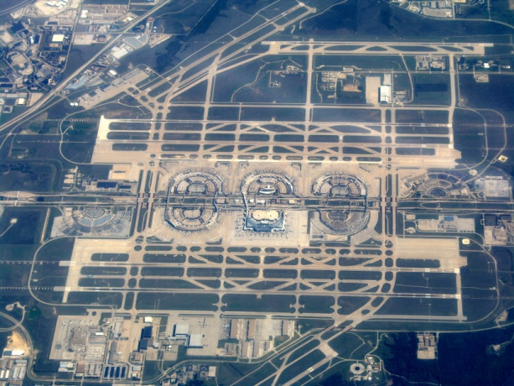***In Dallas she had to change terminals by train. The train is on 2 tracks.***

***It stops at each terminal.***

***She had 2 hours to wait for her flight.***

***She flew from Dallas to London.***

***This flight to London took about 8 hours.***

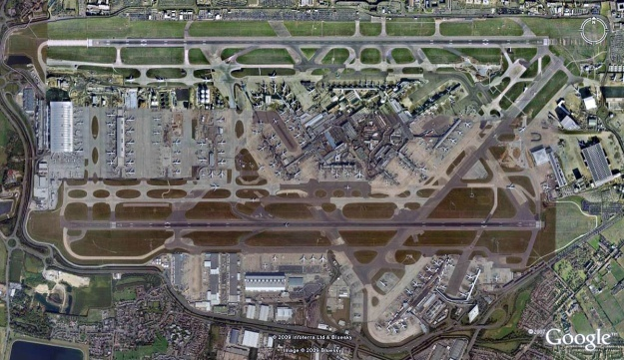***The airport in London is Heathrow*** .

***There she had to change terminals.***

***Amelia’s next flight was from London to Bologna.***

***She took a taxi to the hotel.***

***The whole trip to Bologna took 17 hours.***

***At the end of the flights, she was very tired.***

***Amelia went to Civitanova on the train where my teacher, Rita Bonfigli, was waiting for her.***

***They drove from Civitanova to Caldarola and reached Miss Rita Bonfigli’s house.***