*INFORMATION ABOUT AMELIA*

*I’m going to meet Mrs Amelia*

***Today Mrs Amelia McNeely came to school***

***She is from the U.S.A.***

***The flag of the U.S.A. is composed of 50 stars and 13 stripes.***

***The stars are for the states and the stripes are for the colonies.***

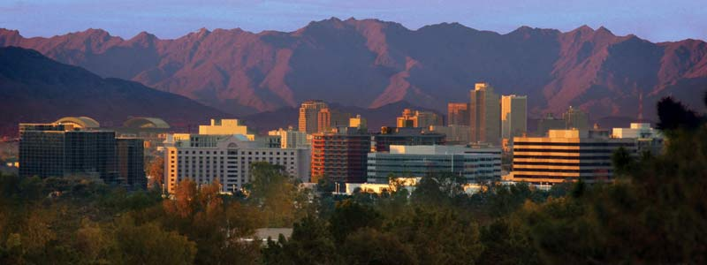

***Amelia is from Phoenix***

***This is a very large city.***

***Phoenix is the 5th largest city in the U.S.A. Phoenix is the capital. In this city there are 4 million people***

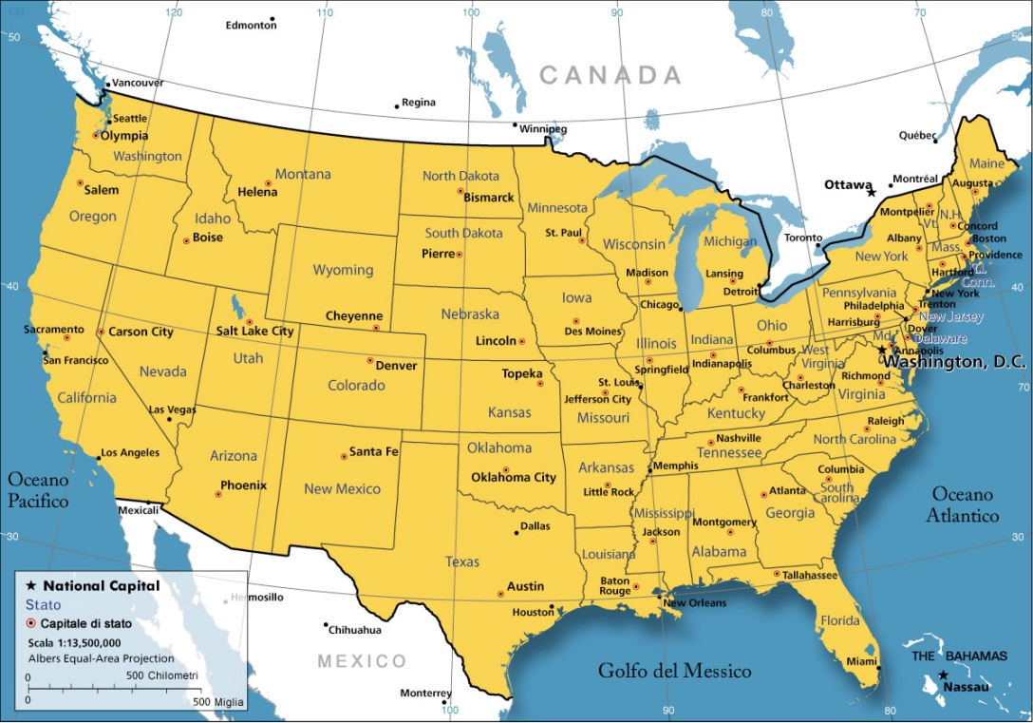

***Phoenix is in Arizona. It is in the Southwest. It is borders on Mexico and California.***

***Phoenix is in a valley. Phoenix is surrounded by mountains. The most famous mountain is Camelback mountain; it has got 2 humps.***

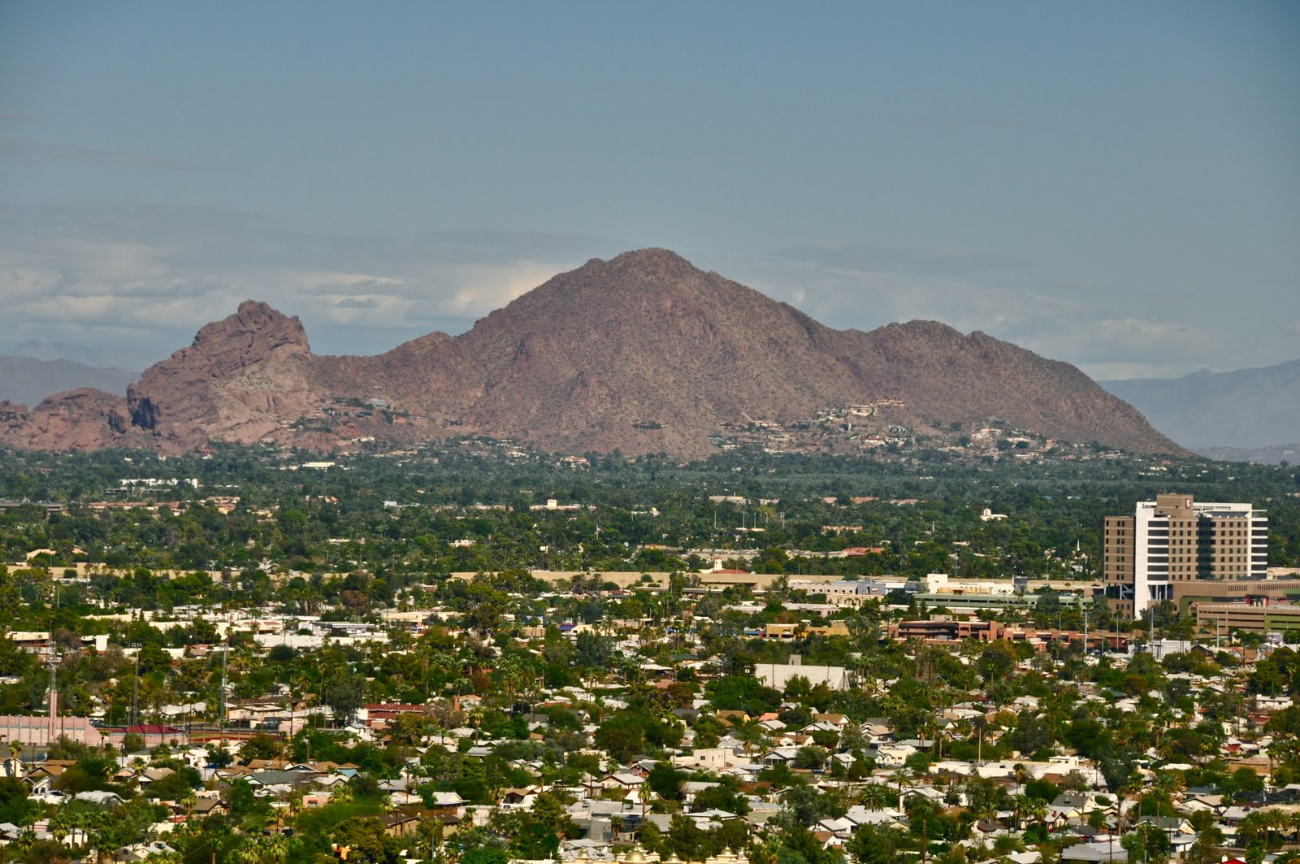

***In the downtown there are:***

***many very tall skyscrapers,***

***the Wells Fargo; this bank has got 17 floors,***

***there are many churches,***

***there are 4 airports; one airport has got 4 terminals.***

***there isn’t a train station.***

***there are many museums: there’s the Heard Museum; this museum is all history about the first Native American Indians.***

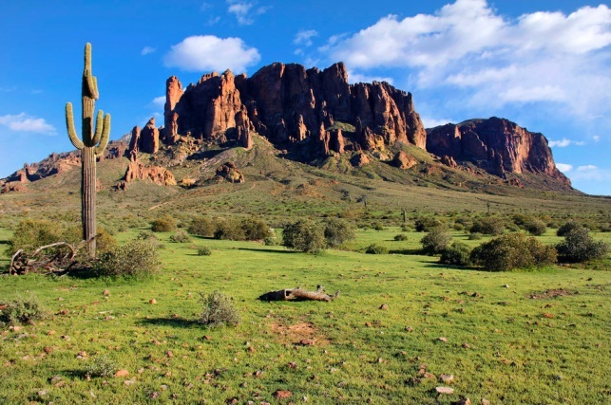***All around there’s a desert.***

***This is a very green desert.***

***In the desert there are many cactus, many rocks, tumble weeds and flowers.***

***The animals in the desert are:***

***Coyotes; Squirrels; Javelinas; Scorpions; Poisonous snakes (skin has the shape of a diamond).***